User Testing Responses

*In this document, I present the findings of user tests conducted so far. I may directly quote, paraphrase, or simply summarize the comments made by testers. To the degree that it is possible, I will try to distinguish between suggestions made by testers and those made by me.*

### **Legend:**

⭐ = Important. If you only skim the summary, read this.

🐛 = Bug. This should or shouldn’t happen, but does or doesn’t.

### **Testing round 2**

**Build: “beta 3_debug”**

**Date: 25-28-20**

**Number of participants: 4+**

#### **🎡 *The wheel:***

* ⭐: The deadzone delay ***needs*** to be more forgiving. This is perhaps the most consistent problem across every playtest session. Some notice it, others don’t, but frustration builds as a result of it.
  + I don’t think this should be a controversial change, because we were already aware yet it feels to me like the most recent build does not have the changes made previously?
* Two players suggested having a button for bringing forth the wheel, separately from the analog stick. Generally, people feel like the right stick is used “for a lot of things” and sometimes it becomes a bit much.
* ⭐🐛: Spinning the wheel quickly produces no sound. This was disappointing to players.
  + With the slight delay before sounds are emitted when singing, it is not really possible to sing in a staccato-like way.
* ⭐: Colors on the wheel need to be rearranged to better accommodate color blind people.
* Players expect that the notes they lock in are saved, even if they didn’t sing them.
  + When questioned further, one player suggested the ability to “prime” notes before singing them.
    - This makes sense, because while you can currently bank a set of notes, you have to sing them first - potentially activating whatever thing you are preparing for prematurely.
* Wheel colors should be a bit more saturated, even when not played. The translucence can make it difficult for players to tell them apart from each other and the background.
  + Remember, the player is using the “unfilled” colors to navigate/correlate with the world, not the filled ones.

#### **🧩 *Puzzles:***

##### *Tutorial:*

* 🐛: It is possible to push the first levitating platform in the tutorial, potentially rendering the puzzle unbeatable.
  + 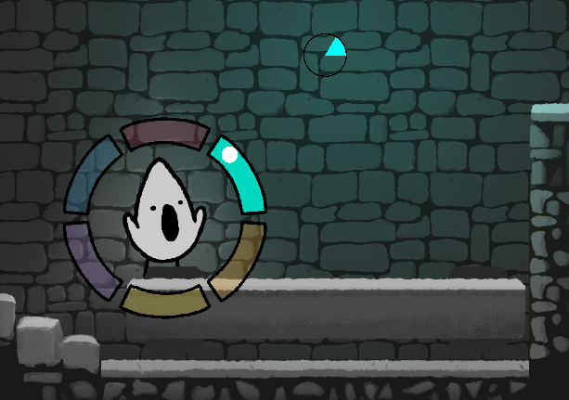

##### *Bells:*

* ⭐🐛: In bell rooms, the player can jump the wall and fall down, getting stuck under the bell.
* In the West Wing bell room, I would like to see the color code moved to the right of the bell.
  + 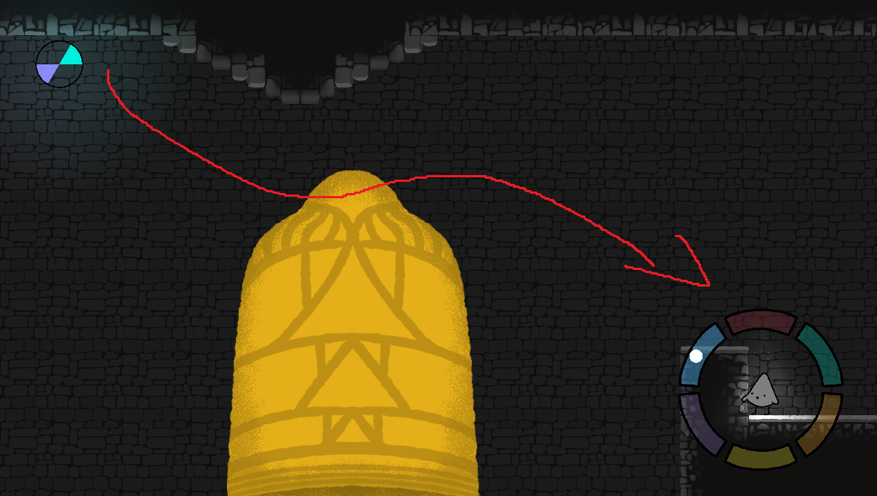
* 🐛: When played, the purple note becomes white, causing some confusion.

##### *Cogbridge:*

* The first cogbridge does create a bit of a roadblock for some people. Most people do eventually figure it out. Conjecture: players willingness to experiment with a roadblock is strongly dependent on whether or not they understand the progression indicator of the elevator torches.
  + Three players initially thought that lowering the bridge meant playing every note simultaneously.
    - One player thought that the starting note should be aligned with the direction/angle of the bridge.
  + Partially as a result of this (and other factors, such as reading-order, I believe) every test person ends up doing the west wing first.
  + Still, the cogbridge could use a bit of juice like sound effects or directional arrows.
  + When solved, however, it is consistently a source of delight for the player!!!
* Opinion: the first cogbridge suggests that “falling in hole under = bad”, yet later on the player is required to do just this.
  + 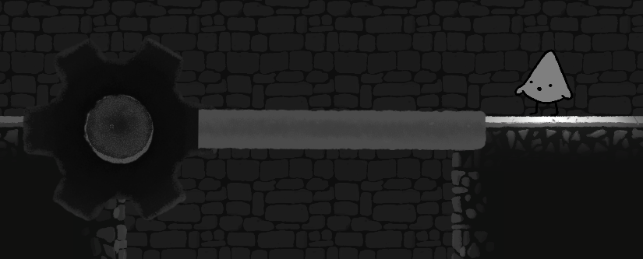
* There are some funky ways of solving the east wing puzzles involving cogbridges. I think this is kind of charming in it’s own way, though.

##### *West Wing:*

* In the second puzzle, when moving towards the barriers leading left, only to balls can be seen (and therefore, moved). This prompted one player to think that he actively had to use the camera to limit which balls were being moved at a time.
* ⭐: The second puzzle does not accurately convey the required pressure sensitivity. Even then, people found it comparatively difficult to whisper compared to yelling.
  + Three players pointed out how the logic of this puzzle is inconsistent with the previous/successive puzzles.
  + Even after discovering pressure sensitivity, one player kept moving back and forth, believing the player position to be relevant to the puzzle/volume.
  + It’s interesting hearing how people have different models of how the volume affects the game. Understandably, some players believed that player proximity to the balls mattered. After all, the puzzle is about volume!
* In the third puzzle, I think the red ball should be a bit more to the right, so players actually notice that the green note pushes it to the left.
  + 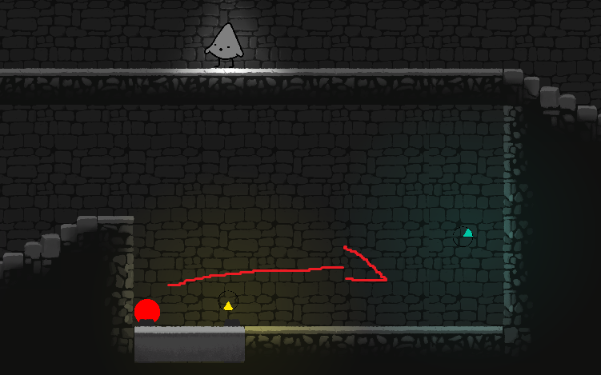
* ⭐🐛: In the third and fourth puzzle, the ball can get stuck under the vertical platforms, breaking the game.
* 🐛: The doors in the fourth puzzle do not actually obstruct the player.
* One player found the final puzzle to be overly punishing. Managing the different note interactions AND the physics of ball rolling was just too much. Suggested making balls less frisky.
* Is there a reason why one platform is governed by red but two are governed by purple in the final puzzle?

##### *East Wing:*

* ⭐: The platform wheel needs to be moved, bigger, or just more visible, as the player wheel will often obscure it.
  + 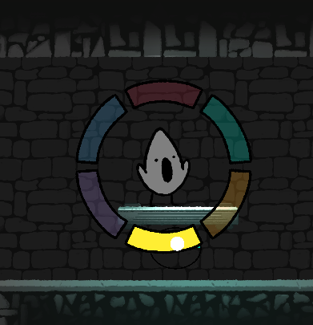
* Two players commented on the friction of the platforms in general, arguing that the platforms felt a bit slippery. This was only really a problem in the east wing puzzles.
* ⭐: The “facing” and expected vector of the platforms caused a lot of confusion and frustration. Anything we can do to inform the player better or align platform movement with ledges would be super good.
  + Two players discovered that in one-note platform wagons, you can simply just cycle through the notes.
    - Similarly, playing every note simultaneously makes the wagons move nonstop.
  + People tend to not “trust” the seemingly unpredictable “elasticity” of the pump wagons.
    - When are the platforms done with their melodic cycle? When are they about to switch direction? This was not clear to players.
  + Some players would cycle through the notes on the platform before actually getting on them.
* ⭐: Bank box puzzle caused a lot of confusion, though mainly due to the colored beads. No colors! Some kind of error sound feedback would be helpful.
  + The door opens before the bead is revealed, making it much less obvious what is going on.
  + Most players eventually made the bank box metaphor connection.
* Bit of inconsistency: when falling into a hole during the cogbridge puzzles, the position of the bridges is reset but the wagon platforms are not.
* 🐛: The final puzzle in the east wing can be potentially unwinnable, if the player falls down, right before the three doors. Respawning on the other side of the gap, it is impossible to call back the platform (as it is out of camera view).

##### *Depths:*

* Generally, people did not struggle too much with this section. People eventually make it through the final puzzle but more through general perseverance and experimentation than with an actual understanding of the logic.
  + Making the bridge leading to yellow a bit more obvious would be a nice improvement.
  + The connection between the purple torch and the bridge is not super clear.
* Beginning of the depths, there should not be a non-interactive on the left side of the first door.
* Arguably, the second interactive torch should have a different color than green?
* In the red torch room, it is very easy to turn on and off different torches at the same time. It’s not necessarily a problem but I think there is some ambiguity (for the player) as to what range is required to activate torches.
* ⭐: Circle of torches in the final room needs to go. Everyone starts singing every note instead of the ones on the final door and it breaks my heart.
* ⭐: Final door can be jumped on before it’s fully open which feels rather anticlimactic.

#### **↪️ *Movement:***

* 🐛: If you jump while on the stairs and while singing, when you reach the ground (while still singing and moving), the legs do not run. They are stuck in the falling position.
* 🐛: Generally speaking, slopes produce some weird effects. Jumping while descending stairs makes for much lower jumps and vice versa.
* ⭐🐛: It is possible to SUPER JUMP in the small sections between elevator hub and the wings.
  + 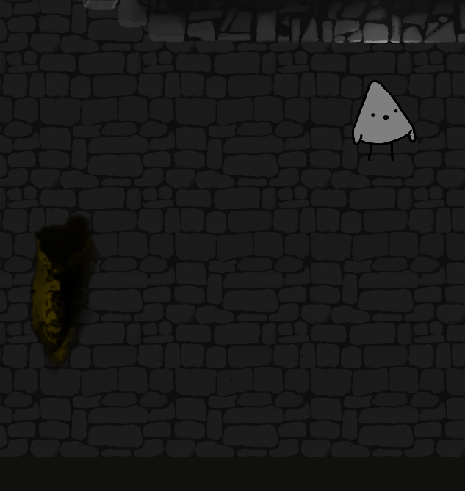

#### **📱 Interface and world:**

* ⭐: Non-interactive objects should not have color. It causes a lot of confusion. Even colors different from the wheel are distracting.
* ⭐🐛: Players requested that the main menu support D-Pad.
  + It is also very sensitive to misclicks: if the mouse clicks anywhere on the screen, the controller is disabled and unresponsive.
* ⭐: The direction of the color slices can be difficult to pick out. Given more time we should (and obviously would) explore alternatives. For now, making them bigger, more visible, less obstructed, and rearranging the color positions would help a lot.
  + One player suggested making the slices look like the wi-fi wave symbol to better indicate direction.
* ⭐: Elevator torches should look different. Right now, it looks like blood coming from some kind of organ.
  + ⭐: Elevator torches should not emit color (except white). Half of the players did not understand or notice the significance of the torches being lit.
* ⭐: At times, especially after warping back to the elevator hub, a wing would be completely missing.
  + I also experienced the depths being gone after making my way through both east and west wings.

#### **🙌 *General feedback:***

* ⭐⭐⭐: People like the game!!!!!!!!!!!!!!!!!!!!!!!!!!!!!!!!!!!!!!!!!!! Can’t stress this enough.
* People like the ability to complete east/west sections in whatever order they like, even if all testers end up doing the west wing first.
* Door and bells are super juicy moments. Awesome!
* Singing without displaying the wheel was rarely used. Very few puzzles require the same note to be played in succession.
* Interestingly, despite discovering chords early on, people still forget about them. Or rather, they underutilize them in certain solutions (like the west wing ball puzzles).
* The ergonomics of this game is a big talking point. Going from one end of the wheel to the opposite was found rather demanding. Same with deadzone disappearance. Players’ right thumb is expected to do a lot of heavy lifting!
* ⭐: When presenting and explaining this game, we should not neglect the fact that it is actually quite demanding. The art style may suggest a more casual appeal, but it does require some effort and skill on the part of the player.
  + This is ***not*** a problem - it’s just something be aware of!

### **Testing round 1**

**Build: “prototype 2”**

**Date: 13-11-20/16-11-20**

**Number of participants: 4**

🎡 ***The wheel:***

* People in general had trouble clearly identifying the colors on the wheel. Especially blue and purple (who are next to each other) were considered incredibly similar if not identical to each other. Three participants had trouble distinguishing red from the background color (brown-ish).
  + This changed when the notes were actually song/highlighted. However, I find it problematic that the player needs to first sing a note in order to identify its color.
  + ⭐ Even if we cannot make the game completely accessible for colorblind people, we would do well to space out colors differently.

*Holding notes:*

* Preferences for the **hold** function were split evenly. Some resonated with notes being “highlighted”, others adapted the metaphor of “holding” notes.
  + However, multiple participants pointed out that when locking in, the notes come undesirably close to the player character, which may be an argument for raising the held notes.

*Filling notes:*

* Similarly, opinions on the **filling** modes were split. One participant found the gradual opacity to be more satisfying, while another preferred the “sound waves” of the other mode.
  + However, both participants pointed out that the “wave” made it much easier to gauge the volume of the singing. In fact, both participants only realized the pressure sensitivity *after* trying the “wave” mode.
  + Two participants described the “wave” as “loading”, which may or may not run contrary to the conceptual model we are going for.
* The hold function in general is a source of wickedness: while participants all managed to make chords, they did so in different ways. It definitely did not “click” immediately with players.
  + The thing is that there are a number of ways of producing a chord. You can:
    - Sing a note, hold it, move on to another note without releasing the trigger;
    - Or hold a note, then sing, then move on to another note;
    - Or hold a note, move to another note, then sing both;
    - Or hold a note, move to another note, hold that, then sing both.
  + ⭐ Ultimately, this may not be a dealbreaker but it is definitely a source of confusion for some, if not all players. I think we are also inconsistent in how we conceptualize chord making. This freedom can be expressive but also a source of confusion.

*Deadzone:*

* ⭐ The deadzone-delay before making the wheel disappear is going to be extremely dependent on the proficiency level of players. Expert players had little trouble navigating the wheel, but players less comfortable/experienced with analog sticks often had the wheel disappear briefly, when crossing the deadzone.
  + Furthermore, even expert players found the wheel ergonomically taxing, as highlighting notes requires the player to fully press the stick in one direction.
    - To add to this, the fact that the wheel needs to be fully pressed to sing notes was seen by some as requiring an undesirable amount of effort. It basically means you have to really yank the stick from one extreme to the others which in and of itself can be ergonomically taxing. Then add on top of that the fact that for “slow” players, there is a deadzone which risks resetting their chord making progress.
* Similarly, one participant noted how there is a lot of deadzone before you actually start singing, when pulling the trigger. And conversely, how there is very little difference between singing quietly and loudly in terms of the trigger being pulled.
  + I am inclined to agree with this and think we should tweak things a bit more.

🧩 ***Puzzles:***

* With every participant going into the game “blind”, two players quickly discovered how to sing without any instruction whatsoever. The participants in question are seasoned players.
* ⭐ Generally speaking, I conclude that the diegetic wheels effectively conveyed instructions to the player. However, as/if we do away with those, results will obviously vary.

*Puzzle #1: Horizontal platform*

* Though varying in speed and elegance of execution, all players quickly understood the implicit goal of crossing the gap with the moving platform in the first puzzle.
  + All players relatively quickly discovered how singing the purple note was required for moving the platform.

*Puzzle #2: First chandelier*

* The first chord-chandelier generally conveyed the idea (“sing two notes”), although with some ambiguity (“simultaneously? in a specific order?”).
* As pointed out, there are a lot of ways to make a chord currently.
* The goal of the puzzle seemed obvious to players (that is, raise the chandelier to pass).

*Puzzle #3: The floating block/box*

* The third puzzle is by far the most interesting but also ambiguous. No two solutions or conceptualizations of the puzzle were the same.
* Two people believed the red block had to be carried through the gap to the next puzzle.
* Three participants all immediately jumped on top of the box, citing the fact that the previous red block (the first puzzle) required them to stand and move.
  + ⭐ I think this observation is super important and reveals the implicit expectation of some kind of universal puzzle language. At least, we should not give the same color to objects that do wildly different things!
* All participants seemed to think that the character had to stand on the block and possibly manipulate its angle or direction.
  + Participants expressed confusion that they were able to raise the block vertically but not horizontally.
  + No participants discovered the intended use of the sloped ceiling.
    - One participant expressed dismay when the block was lifted, hit the ceiling and skated towards the gap. This was seen as a setback, not an advancement.
* Only one participant retroactively understood the block as a stepping stone to advance.

*Puzzle #4: Second chandelier*

* Not much to say here. Having made the first chord, the second chandelier felt like a natural progression of difficulty.
  + One player did fall down while singing. This actually made the puzzle impossible to complete, as the chandelier was out of singing range and so could not be lowered again.

**↪️ *Movement:***

* ⭐ Jumping while singing was considered awkward and/or difficult by all testers.
  + Note that this build did not include the option for singing without the wheel. Even so, it is something to keep in mind when designing puzzles.

**📐 *The character:***

* The character was generally described as cute and gendered as “he”, “her”, and “it” by different participants.
  + Its appearance was described as a tooth, an ice cream cone, a ghost.
    - And by one participant, as a KKK hat.

**🙌 *General remarks:***

* People like our game! Hooray!
* Discussing the game afterwards produced a multitude of ideas and suggestions from the participants: including melodies, harmonizing with the world, having more notes available, including some ambient sounds.
  + We have covered a lot of these ideas ourselves, but it is nice hearing them repeated from players. This to me demonstrates that the concept is intelligible and interesting to people.
* Worth mentioning is how people actually perceived the causality of the game as one “where you do things with sounds.” No one made the cynical (if correct) remark that the sound is merely accidental/epiphenomenal to the puzzle causality/logic.
* One participant noted how the ‘theremin’ quality of the notes would get frustrating.